### Quiz Question

Which of the following is not accurate about entropy?

1. The more knowledge one has, the less entropy
2. The less knowledge one has, the less entropy
3. The less knowledge one has, the more entropy

### Quiz Question

Which function will help us turn products into sums?

1. sin
2. cos
3. log
4. exp

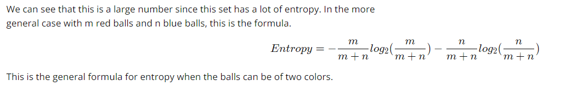

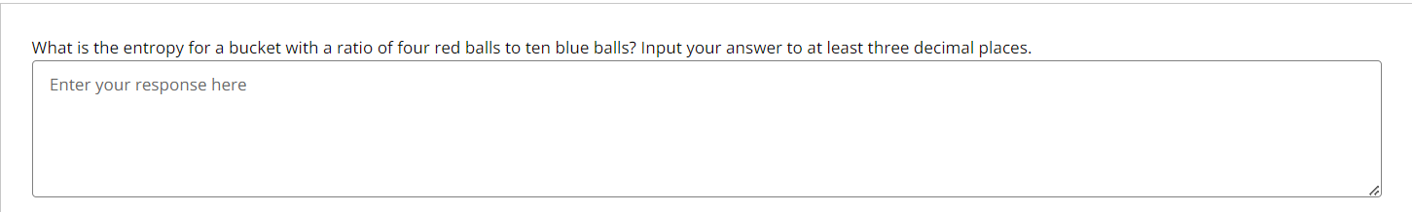

Answer:

To calculate the entropy, we use the formula:

Entropy = - (m / (m + n)) * log₂(m / (m + n)) - (n / (m + n)) * log₂(n / (m + n))

where:

m = 4 (red balls)

n = 10 (blue balls)

m + n = 4 + 10 = 14

Now, we calculate the probabilities:

P_red = 4 / 14 ≈ 0.2857

P_blue = 10 / 14 ≈ 0.7143

Now, we apply the values in the formula:

Entropy = - (0.2857 * log₂(0.2857)) - (0.7143 * log₂(0.7143))

We calculate the logarithms:

log₂(0.2857) ≈ -1.807

log₂(0.7143) ≈ -0.494

Now, we multiply:

0.2857 * (-1.807) ≈ -0.516

0.7143 * (-0.494) ≈ -0.353

Finally, we sum them:

Entropy = 0.516 + 0.353 = 0.863

So, the entropy for this case is 0.863 (rounded to three decimal places).

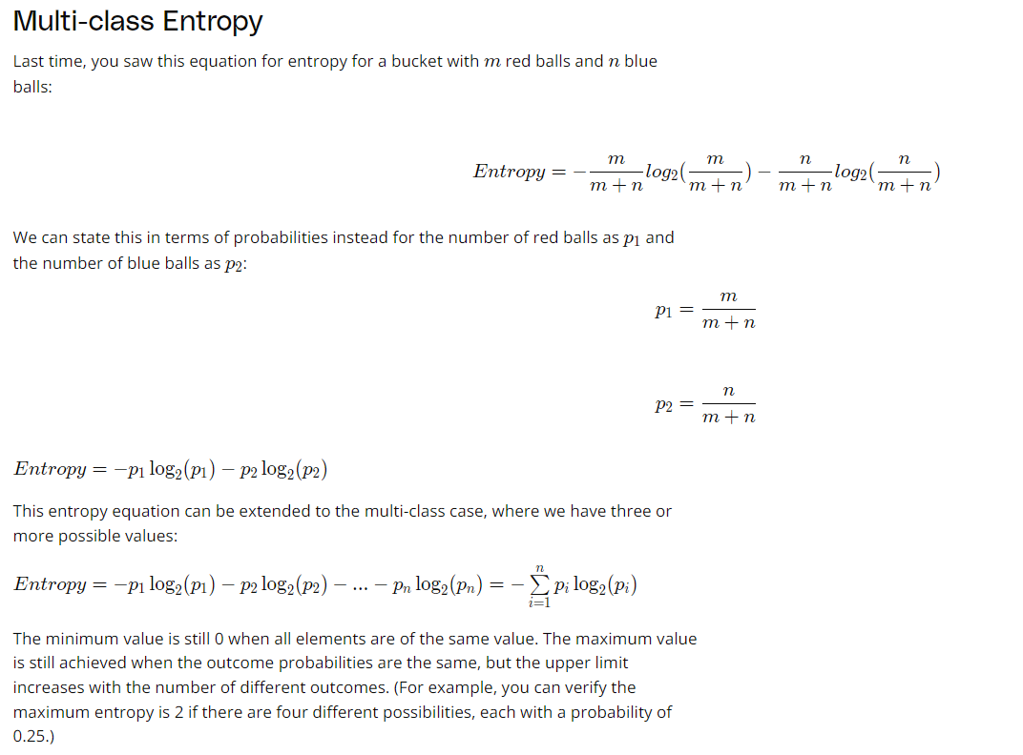

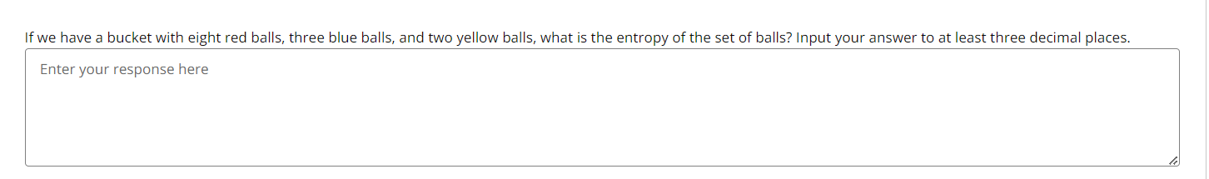

Answer: _ _ _ _ _ _ _ _ _ _ _ _

Total number of balls:  
8 (red) + 3 (blue) + 2 (yellow) = 13

Probabilities:  
Red: 8/13 ≈ 0.615  
Blue: 3/13 ≈ 0.231  
Yellow: 2/13 ≈ 0.154

Logarithms (base 2):  
log2(0.615) ≈ -0.700  
log2(0.231) ≈ -2.110  
log2(0.154) ≈ -2.700

Multiply each probability by its logarithm:  
0.615 × (-0.700) ≈ -0.431  
0.231 × (-2.110) ≈ -0.487  
0.154 × (-2.700) ≈ -0.415

Sum:  
-0.431 - 0.487 - 0.415 = -1.333

Entropy ≈ **1.333**